**12 Common Physical Therapy Treatments and Modalities**

By [Brett Sears, PT](https://www.verywellhealth.com/brett-sears-2695988)

Updated on January 16, 2023

 Medically reviewed by [Laura Campedelli, DPT](https://www.verywellhealth.com/laura-campedelli-pt-dpt-4776034)

[Physical therapists](https://www.verywellhealth.com/physical-therapy-4014670) have a range of modalities, or treatment methods, they can choose from to help reduce pain and inflammation, as well as improve your endurance, [strength](https://www.verywellhealth.com/muscle-strength-measurement-2696427), and [range of motion](https://www.verywellhealth.com/overview-range-of-motion-2696650) as you rehab from a musculoskeletal injury or movement dysfunction.

Heat application, electrical stimulation, traction, and massage are just a few of the physical therapy modalities that may be used at different stages of your recovery. While some modalities may only be available during a treatment session, others can be done at home.

This article explores 12 common physical therapy modalities, including how and why they are used. If your therapist recommends one for you, they should be prepared to explain the reason for using the modality and what to expect from treatment.

Exercise

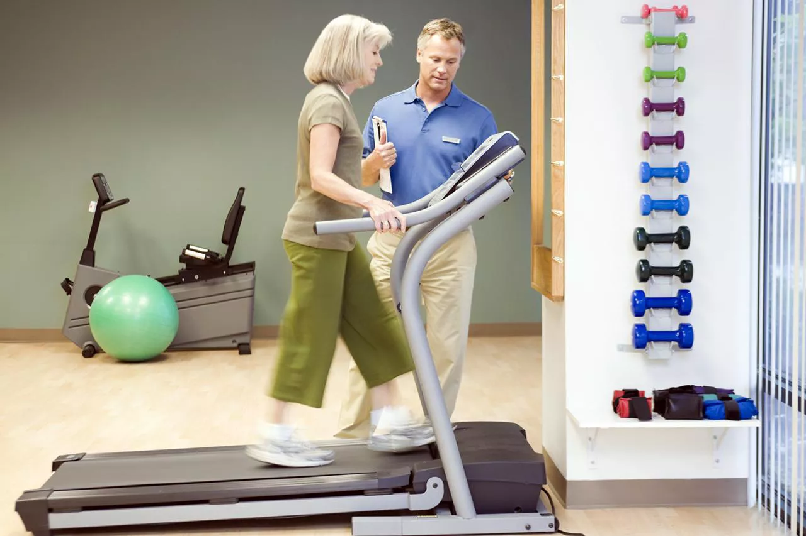

Upper Cut Images / Getty Images

Exercise is a controlled physical stress applied to the body to help improve strength, range of motion, or flexibility.

Exercise can be [passive or active](https://www.verywellhealth.com/active-and-passive-pain-management-5205485).

* **Passive exercise** is one that requires you to simply relax while another person, like a physical therapist, applies the stress. One example of this is a hamstring stretch where a person lifts your leg to elongate the hamstring muscle on the back of the thigh.
* **Active exercise**is movement you perform under your own power. Walking on a treadmill, [hip strengthening exercises](https://www.verywellhealth.com/advanced-hip-strengthening-exercises-2696611), or [straight leg raising](https://www.verywellhealth.com/how-to-the-straight-leg-raise-2696526) exercises are all active exercises.

If you attend physical therapy in a clinic, at home, or while in the hospital, you will likely be engaged in some form of exercise to help improve your mobility. Home exercises are often also prescribed.

The home program is a group of exercises that you perform on your own. They can be very important in helping you return to normal function.

Ultrasound

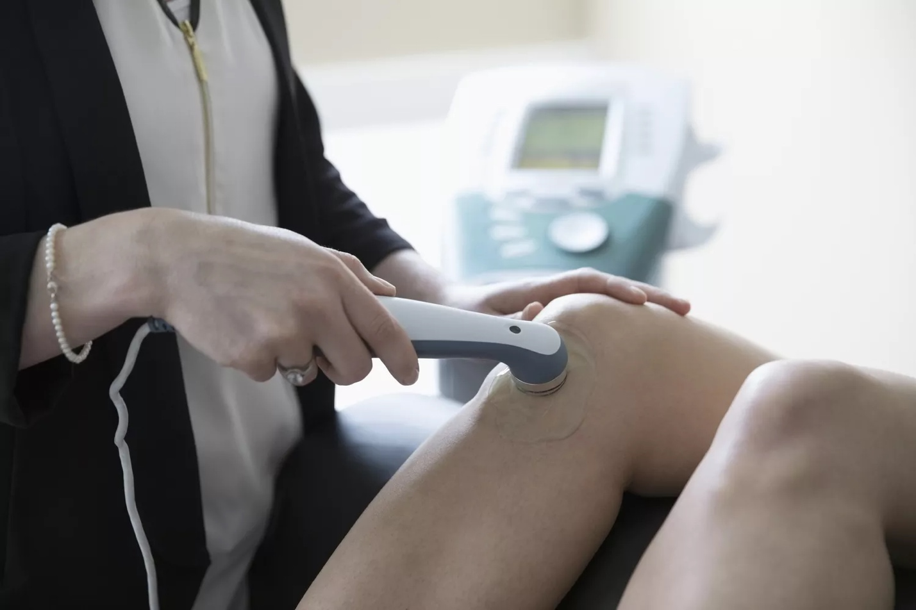

 Hero Images / Getty Images

[Ultrasound](https://www.verywellhealth.com/therapeutic-ultrasound-in-physical-therapy-2696419) is a deep heating treatment used to treat many musculoskeletal conditions like [sprains](https://www.verywellhealth.com/strain-vs-sprain-2696546), strains, or [tendonitis](https://www.verywellhealth.com/tendonitis-definition-causes-treatment-2696478).1

Ultrasound is administered by your physical therapist using an ultrasound machine. A small amount of gel is used so the ultrasound waves are absorbed into the skin and muscles. A wand called a sound head is pressed gently against your skin and moved in small circular sweeps near the site of injury.

Electrical Stimulation and TENS

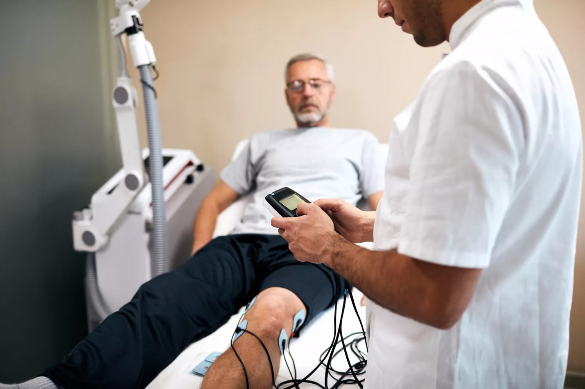

vgajic / Getty Images

[Electrical stimulation](https://www.verywellhealth.com/what-is-tens-and-how-does-it-work-2564548) is occasionally used in physical therapy to help decrease pain around injured tissue.2 Transcutaneous electrical neuromuscular stimulation (TENS) is one well-known form.

There are two theories about how stimulation works: the gate theory and the opiate theory.

**Gate theory.**Researchers published this theory in 1965 and suggested that the spinal cord acts as a neurological 'gate' that either blocks pain signals or allows them to continue on to the brain. The gate in the spinal cord allows pain signals traveling via small nerve fibers to pass while signals sent by large nerve fibers are blocked.3 TENS may activate this mechanism during the flow of electrical current.

**Opiate theory.**The nervous system naturally produces three opioids that act as neurotransmitters and neuromodulators to produce analgesia. TENS may activate this system to reduce pain, however, most research has used animal models so more research is needed to verify the effects on people.

Other forms of electrical stimulation may be used to contract muscles. This is called neuromuscular electrical stimulation (NMES) and is used to help your injured muscles "relearn" how to function properly.4

TENS is not recommended if you:5

* Have a [pacemaker](https://www.verywellhealth.com/pacemakers-what-you-should-know-1745231) or other electrical or metal implant in your body
* Are in the early stages of pregnancy
* Have [epilepsy](https://www.verywellhealth.com/epilepsy-causes-risk-factors-1204427) or a heart problem
* Have an overactive bladder

Traction

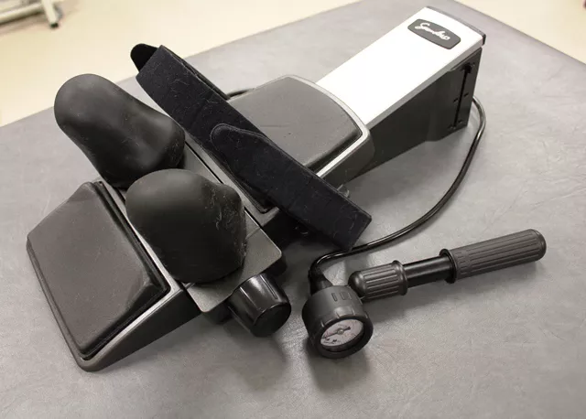

Brett Sears, 2011

Traction is used in the treatment of [low back pain](https://www.verywellhealth.com/physical-therapy-and-exercises-for-low-back-pain-2696180)6 and neck pain to help decrease pain and improve mobility in the spine.

To use lumbar traction, you must be strapped into a mechanical machine. There is a vest that helps support your ribs and another device that wraps around your pelvis. The vest and pelvic device are stabilized with straps, and a mechanical force is applied with a machine.

Cervical traction is applied in either the sitting or lying position. If sitting, a harness is attached to the head and a pulley system is used with a small weight attached. The weight provides the traction force while you sit comfortably in a chair.

In lying, or supine, traction, a specific device is used. You must lie down on your back and strap your forehead into the device. Then, a pneumatic pump is used to help provide the traction force to your neck.

Theoretically, traction helps to separate the joints and disc spaces in the low back or neck, which in turn helps to decrease pressure on spinal nerves.

Joint Mobilization



Hero Images / Getty Images

[Joint mobilization](https://www.verywellhealth.com/joint-mobilizations-in-physical-therapy-5209535) occurs when your physical therapist passively moves the joints of your body in specific directions. This can help to decrease pain and improve mobility.7

While you may think of your joints as moving hinges, there is a gliding motion that also occurs between the joints. This gliding motion is increased during joint mobilizations. The degree to which your therapist moves each joint depends on the amount of pressure and the direction of force applied to the joint.

While joint mobilization is a passive treatment, your physical therapist can teach you self-mobilization techniques so you can manage your condition independently. These techniques can help you return to normal function quickly and help prevent future problems.

Massage

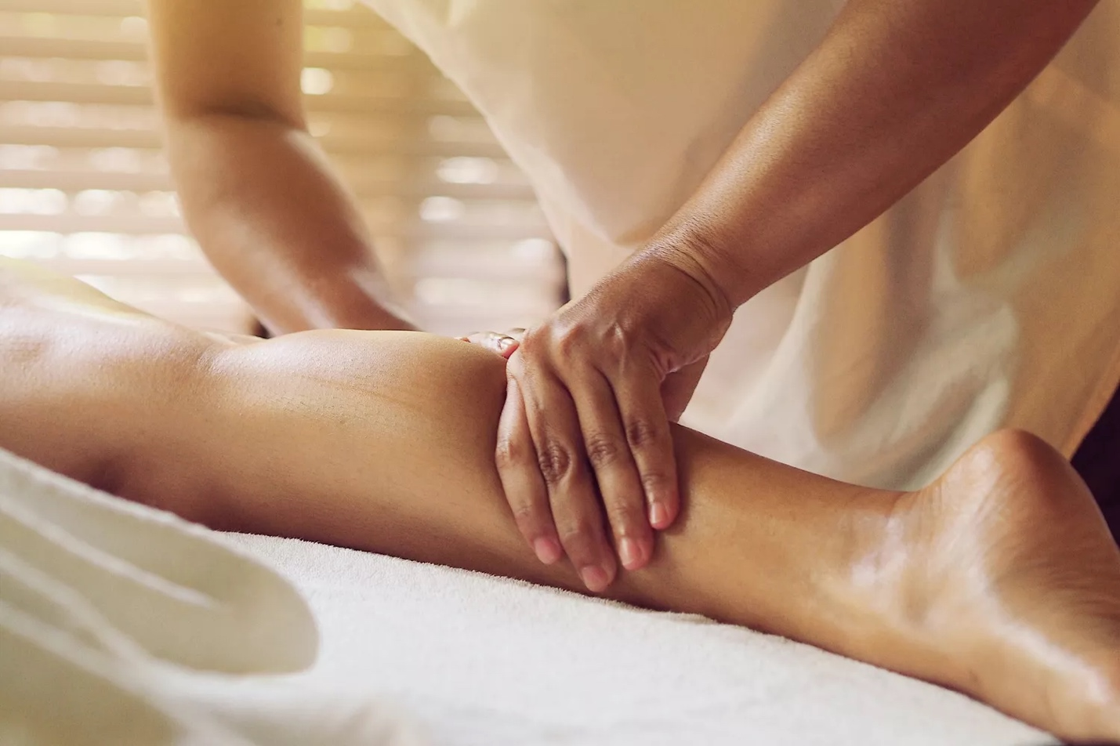

 Mallika Wiriyathitipirn / EyeEm / Getty Images

[Massage](https://www.verywellhealth.com/massage-therapy-5212944) is the process of rubbing and kneading muscles and joints to help decrease pain, improve circulation, and decrease muscle tension.8

Massage therapists use their fingers, hands, forearms, and elbows to manipulate the muscles and other soft tissues of the body. A few different types of massage include Swedish, deep tissue, and sports massage.9

* **Swedish massage:**The therapist uses long strokes, kneading, deep circular movements, vibration, and tapping.9
* **Deep tissue massage:** The therapist's focus is more targeted, working on specific areas of concern or pain. These areas may have muscle “knots” or places of tissue restriction.9
* [**Sports massage**](https://www.verywellhealth.com/sports-massage-what-are-the-benefits-1337670)**:** This type of massage targets the muscles that are used in a specific sport. It uses various techniques to decrease [muscle pain](https://www.verywellhealth.com/muscle-pain-what-you-should-know-190093) and improve recovery, range of motion, and flexibility to support athletic performance.

Heat

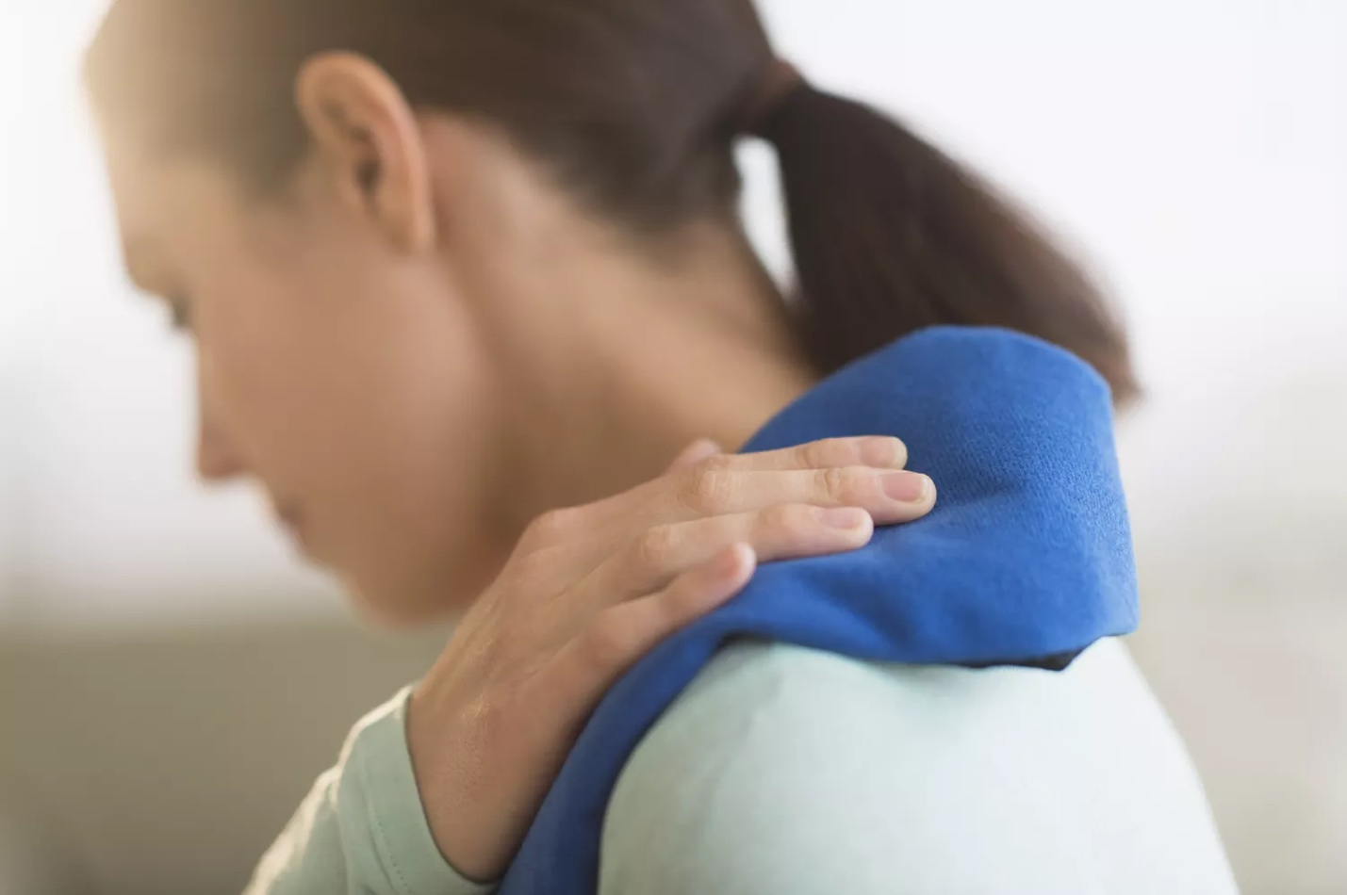

Tetra Images / Getty Images

Moist heat, or [hot packs](https://www.verywellhealth.com/hot-packs-physical-therapy-modalities-2696130), may be applied to your body if you have an injury or after physical therapy exercises. The heat helps to increase circulation to the injured tissues, relax the muscles, and provide pain relief.10

In a physical therapy clinic, hot packs are kept in a device called a hydrocollator. This is a large tank of hot water. The hot packs are cloth packs filled with a sand, clay and silica mixture. They absorb the hot water and are wrapped in terry cloth covers and towels before being applied to your body.

The hot pack is usually kept on the injured body part for 15 to 20 minutes.

Caution must be used when using hot packs as the skin may suffer burns if insufficient toweling is used during the application of the heat.

Ice



 PhotoAlto / Odilon Dimier / Getty Images

If you have an injury, [cold packs or ice](https://www.verywellhealth.com/what-is-rice-190446) may be applied to your body to help decrease pain and control inflammation. Ice is usually used during the acute or initial phase of injury to limit localized swelling around tissues.

Cold packs are usually applied for 15 to 20 minutes.11 Like hot packs, sufficient toweling is needed to prevent skin damage from getting too cold.

Iontophoresis

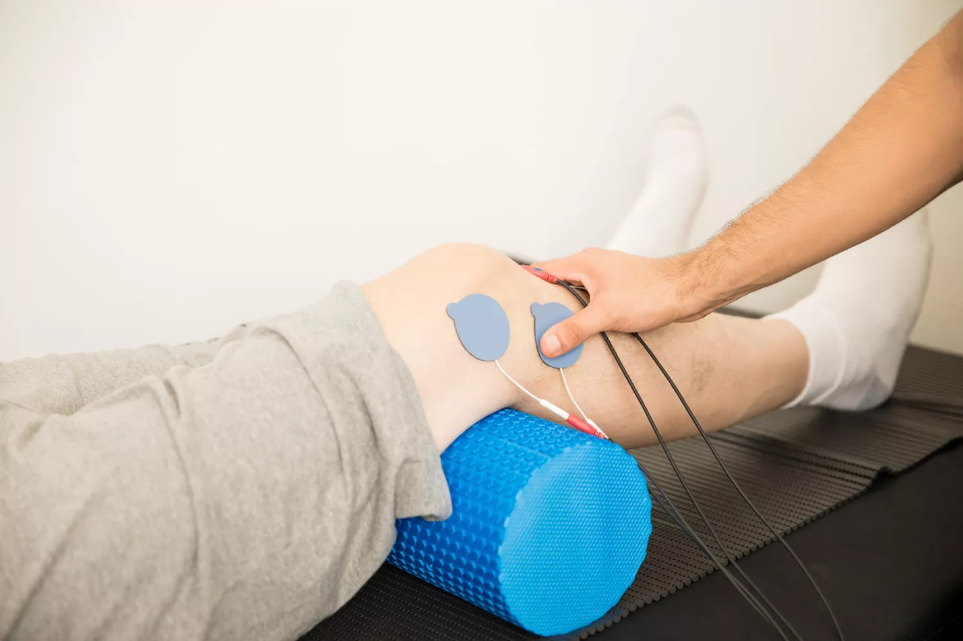

 Antonio_Diaz / Getty Images

[Iontophoresis](https://www.verywellhealth.com/iontophoresis-2696160) is a form of electrical stimulation that is used to deliver medication across the skin to inflamed or injured tissues.

Most often, a steroid like dexamethasone is used in the treatment of inflammation. This steroid can help decrease the pain and swelling of tissues that occurs when they're inflamed.

Iontophoresis can be used in the treatment of other conditions as well, depending upon the medication that is used during treatment. It is not a replacement for active physical therapy but can be added as part of an overall plan.12

Laser or Light Therapy

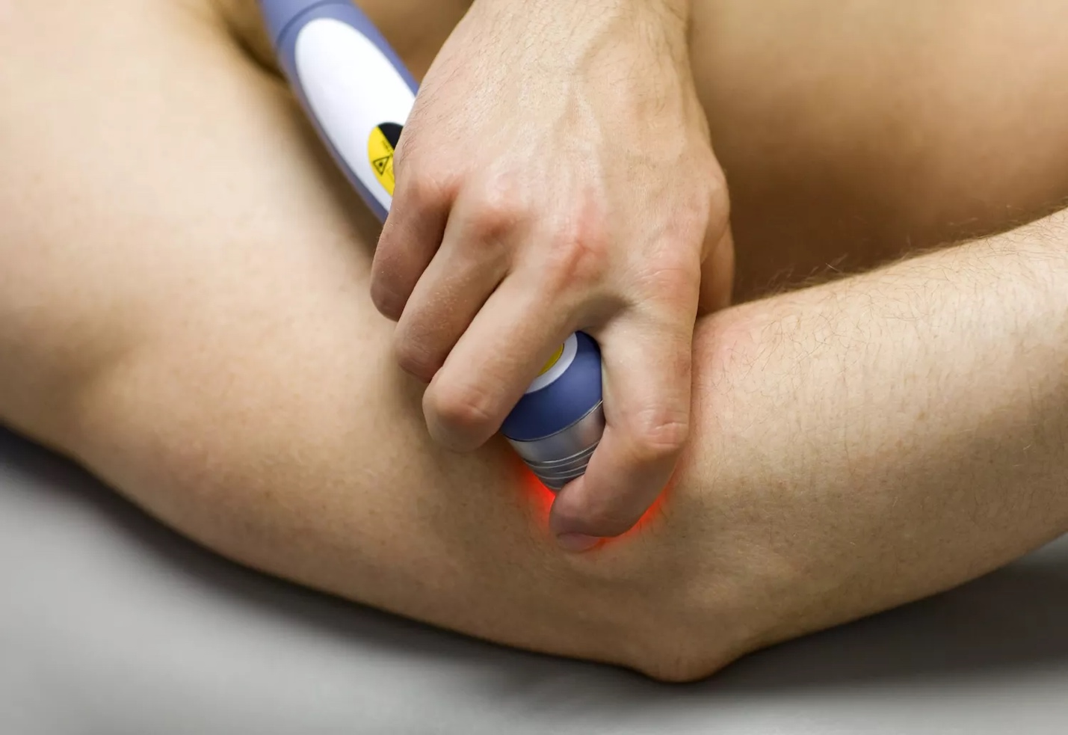

BanksPhotos / Getty Images

Light therapy involves using light at a specific wavelength to help improve the healing process of injured tissues.11 The treatment is painless and usually lasts for one to three minutes.

To apply light therapy, your physical therapist will hold the light-emitting wand directly over your injured body part and press a button to activate the light.

Light therapy can be used in the treatment of chronic pain, inflammation, or wound healing.13

The theory behind light therapy is that photons of light carry energy, and this energy applied to injured tissues can help improve cellular processes and speed healing or decrease pain.

Kinesiology Taping

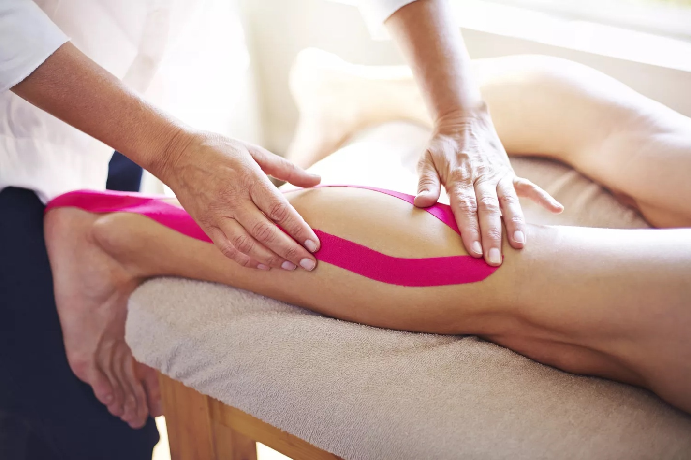

 Caiaimage / Trevor Adeline / Getty Images

[Kinesiology taping](https://www.verywellhealth.com/kinesiology-tape-in-physical-therapy-2696435), or K-tape, is often used by physical therapists to augment your rehab program.14 The tape is made of a flexible fabric that stretches and pulls as you move.

Kinesiology tape is applied to the skin, and it can be kept in place for a few days.

It may be used for various purposes, including:

* Muscle inhibition
* Muscle facilitation
* Bruising and swelling management
* Pain relief

K-tape is a newer treatment modality, and there is mixed evidence of the effectiveness of taping for different body regions and conditions.15 A 2019 study showed taping was effective in relieving pain from knee osteoarthritis, but more research is needed.16

Whirlpool

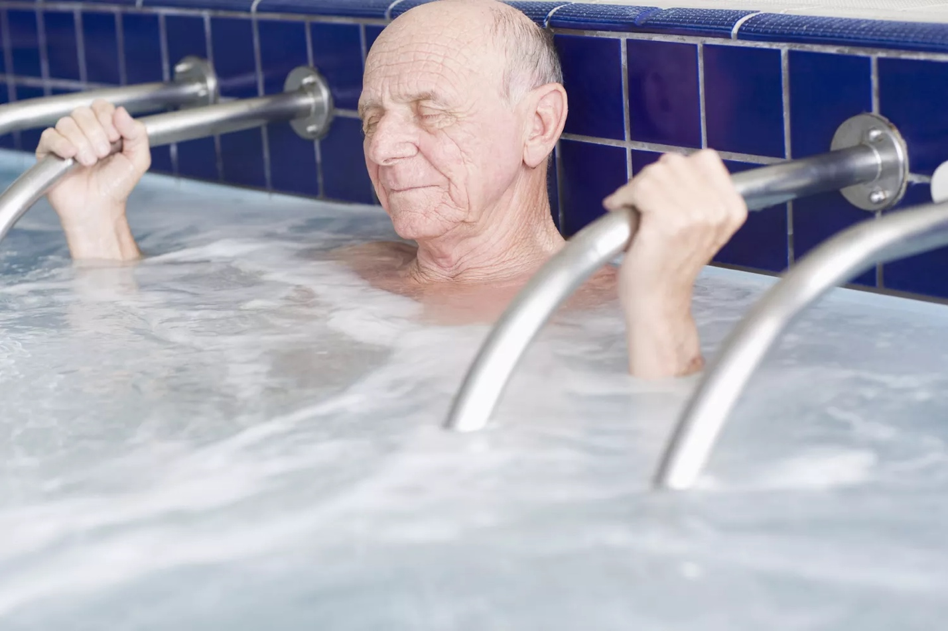

 Radius Images / Getty Images

[Whirlpools](https://www.verywellhealth.com/contrast-bath-in-physical-therapy-2696628) are a form of hydrotherapy and are used to help improve circulation, maintain clean wounds, or control inflammation.17

Mooventhan A, Nivethitha L. [Scientific evidence-based effects of hydrotherapy on various systems of the body](https://doi.org/10.4103/1947-2714.132935). *N Am J Med Sci*. 2014;6(5):199–209. doi:10.4103/1947-2714.132935

Whirlpools can be hot or cold. The usual temperature for a hot whirlpool is between 98 and 110 degrees Fahrenheit. A cold whirlpool bath is typically 50 to 60 degrees Fahrenheit.

Whirlpool baths have a motor or agitator that helps move the water around the body part that is being treated. This motion can have a soothing effect, and can also be used in the treatment of wound debridement.

A typical whirlpool session involves placing your body part to be treated into the water and relaxing while the water swirls around it. Gentle exercises can be performed to help improve motion around the body part while it is in the whirlpool.

Care must be taken to ensure that the whirlpool bath is not too cold or hot, as temperature extremes can damage your skin during treatment. Hot whirlpools may not be safe for people with certain health conditions, such as pregnancy, high blood pressure, and other heart conditions, so talk with a healthcare provider if you have these conditions.1819